Here is a link of my Repl.it:

<https://repl.it/@seanposton4/Assignment-1>

It doesn’t print out nicely, so I will include a screenshot of the output in NetBeans

**Time Complexity:**

Loops: 1 while loop (n)

Nested Loops: 3 double for loops (3n2)

3n2 ­ + n = **O(n2)**

**Source Code:**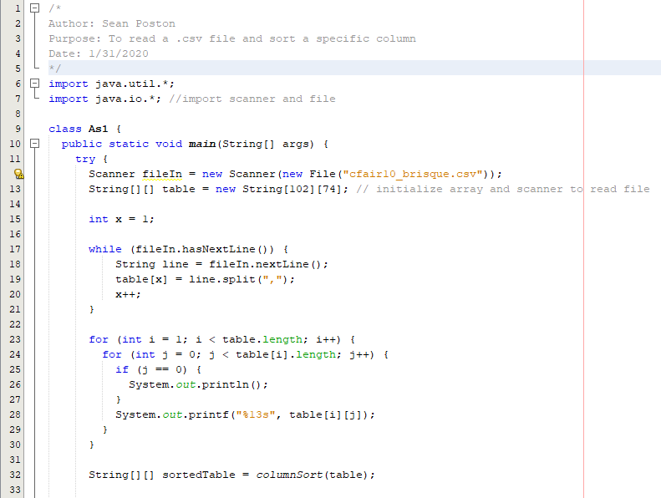  
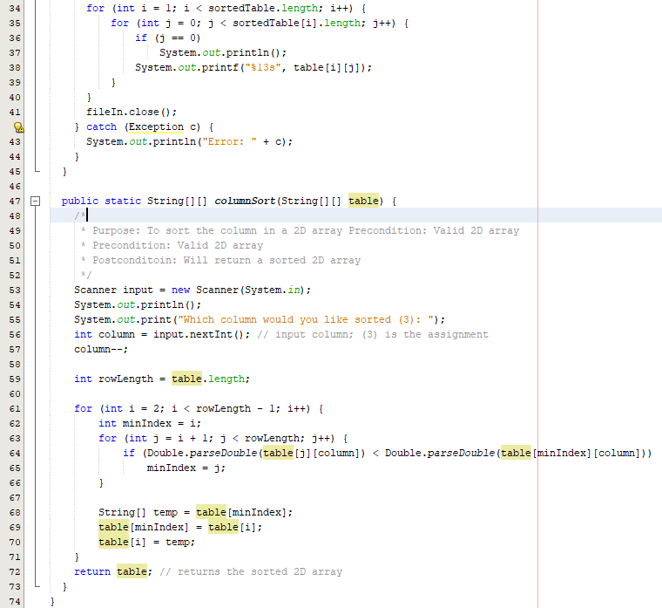

**Output:**

